

Story 5

Flu Epidemic

Version 0.1

28.11.2005

Your partner to set your business into real-time

Inhaltsverzeichnis

Story 5 1
Abbildungsverzeichnis 2
Tabellenverzeichnis 2
1 Starting point 3
2 Preparation 3
3 The Transport 6
4 Acceptance of Shipment 6
5 Conclusion 7

Abbildungsverzeichnis

Fehler! Es konnten keine Einträge für ein Abbildungsverzeichnis gefunden werden.

Tabellenverzeichnis

Fehler! Es konnten keine Einträge für ein Abbildungsverzeichnis gefunden werden.

- Starting point

The first case of a mutated bird flu virus has been spotted in Spain. A/H5N1
has crossed itself with a human flu virus and an epidemic among human citizens in Spain broke out. The new virus strain has shown itself resistant against Oseltamivir (alias Tamiflu) and a high demand on Pernazal arised. Big amounts of Pernazal have been ordered from the central storage depot in Vienna to supply the citizens with sufficient medication.

The order, sent out on the 7th November, covers 50.000 units of the highly efficient Pernazal. The delivery has to be accomplished as soon as possible to ensure a primary care – the deadline is the 10th November 2005. The target depot in Spain is in Barcelona.

Order | 07.11.2005
Delivery Date | 10.11.2005
Product | Pernazal, 50.000 units
(OrderReceived, OrderConfirmed)

A pandemic hysteria has arisen throughout Europe and the demand increased dramatically. The result of this high demand is that there is not enough Pernazal left to ship as fast as it is needed from Vienna.

MediTransCare made the decision to reroute Pernazal from the British, German and France storage depots to Spain. The transport costs are irrelevant because of the huge expected sales volume. The delivery time is the critical factor in this case!

- Preparation

MediTransCare sends out an offer for the transport to Spain:

from central storage depot in Vienna 20.000 units
from storage depot in Paris 20.000 units
from storage depot in Rome 10.000 units

Originally it was planned to ship 10.000 units from Frankfurt instead of Rome. After the suspicion of a flu case in Germany the demand after Pernazal exploded. To be prepared for an epidemic MediTransCare decided not to touch the German depots.

Departure | Central storage depot in Vienna  08.11.2005
Arrival | Storage depot in Barcelona  08.11.2005
Transportation budget | EUR 3000,--
Delivery temperature for Pernazal | MinTemp: -20  MaxTemp: -10

Departure | Storage depot Paris  08.11.2005
Arrival | Storage depot Barcelona  08.11.2005
Transportation budget | EUR 3000,--
Delivery temperature for Pernazal | MinTemp: -20  MaxTemp: -10

Departure | Storage depot in Rome  08.11.2005
Arrival | Barcelona Airport  08.11.2005
Transportation budget | EUR 2000,--
Delivery temperature for Pernazal | MinTemp: -20  MaxTemp: -10
(ShipmentTenderIssued)

The transportation for the goods has been tendered for each storage depot. The carrier Weiss (433) accepts the transport for Pernazal from Vienna and Paris. The carrier Anger (532) accepts the transport from Rome.
(ShipmentTenderRejected, ShipmentTenderAccepted)

MediTransCare creates a transport plan for the route. The supply is transferred from the depot to the nearest airport and loaded into cargo planes. After all Pernazal supplies arrived in Barcelona carrier Weiss delivers the whole cargo to the storage depot in Barcelona
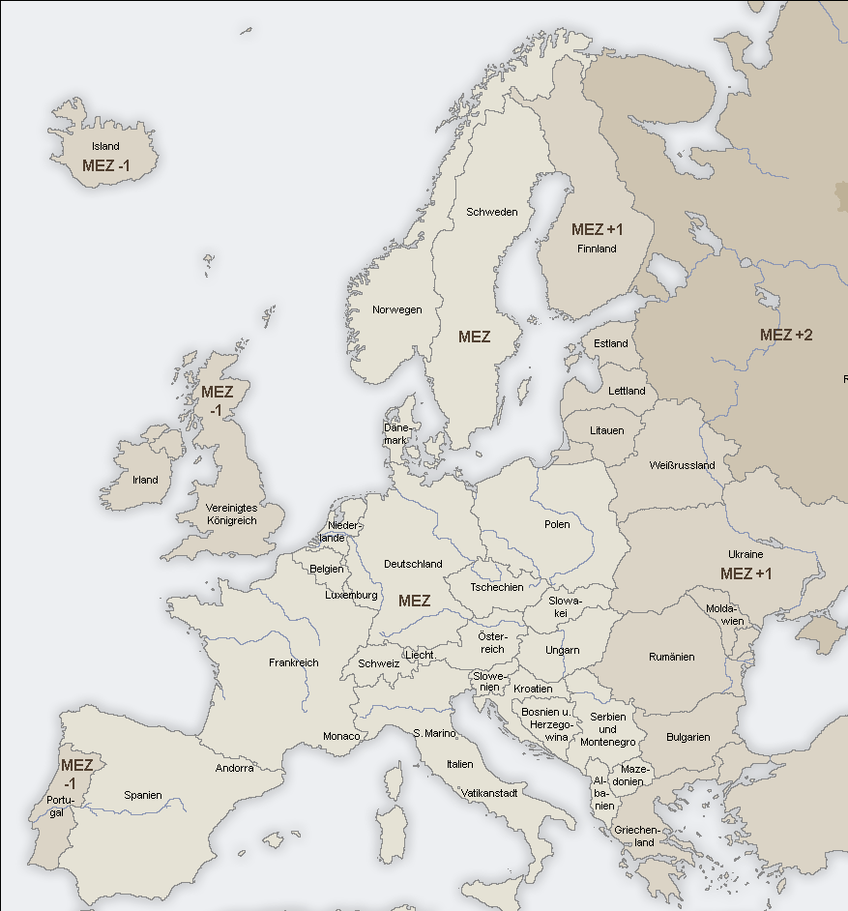
Weiss
Weiss
Anger
Weiss

To ensure Qualitiy standards, like always, Meditranscare adds DataLoggers to the package that logs in 60 minutes intervals the current temperature between the layered goods in the polystyrene package to achieve meaningful results.
(DataLoggerConfigured)

The parameters for the planned transport look like as follows:

From Vienna to Barcelona Airport:
CarrierId | 433 (Weiss)
TransportId | 48101
PlannedShipped | 2005-11-08T07:00:00
PlannedDelivered | 2005-11-08T14:00:00
EarlyBuffered | 2005-11-08T07:00:00
LateBuffered | 2005-11-08T16:00:00
Route | Vienna To Barcelona Airport
Miles | 1400
PlannedFreightCosts | 3000

From Paris to Barcelona Airport:
CarrierId | 433 (Weiss)
TransportId | 48102
PlannedShipped | 2005-11-08T07:00:00
PlannedDelivered | 2005-11-08T13:00:00
EarlyBuffered | 2005-11-08T07:00:00
LateBuffered | 2005-11-08T16:00:00
Route | Paris To Barcelona Airport
Miles | 580
PlannedFreightCosts | 2000

From Rome to Barcelona Aiport:
CarrierId | 532 (Anger)
TransportId | 48103
PlannedShipped | 2005-11-08T07:00:00
PlannedDelivered | 2005-11-08T12:00:00
EarlyBuffered | 2005-11-08T07:00:00
LateBuffered | 2005-11-08T16:00:00
Route | Rome To Barcelona Airport
Miles | 800
PlannedFreightCosts | 2500

From Barcelona Airport to storage depot in Barcelona:
CarrierId | 433 (Weiss)
TransportId | 48104
PlannedShipped | 2005-11-08T16:00:00
PlannedDelivered | 2005-11-08T17:00:00
EarlyBuffered | 2005-11-08T14:00:00
LateBuffered | 2005-11-08T17:00:00
Route | Vienna To Barcelona Airport
Miles | 15
PlannedFreightCosts | 200

- The Transport

All carriers manage to start the transports in time from the storage depots on the 8th November. The flights can be accomplished without any delays or problems. On the airport in Barcelona the cargos are stored temporarily until all partial shipments arrive.
Afterwards the carrier Weiss delivers the shipment from the airport to the storage depot in Barcelona

Departure | 07:00, 08.11.2005 storage depot Vienna
Arrival | ca. 14:15, 08.10.2005 airport in Barcelona

Departure | 07:00, 08.11.2005 storage depot Paris
Arrival | ca. 12:45, 08.10.2005 airport in Barcelona

Departure | 07:00, 08.11.2005 storage depot Rome
Arrival | ca. 14:15, 08.10.2005 airport in Barcelona

Departure | 16:15, 08.11.2005 airport Barcelona
Arrival | ca. 16:45, 08.10.2005 storage depot in Barcelona

- Acceptance of Shipment

The quality check shows no noticeable problems and the quality standard for Pernazal is ensured.
(TransportStart, TransportEnd, DataLoggerRead, ShipmentAudit)

- Conclusion

MediTransCare gets an order and has not enough units left in its central storage depot.
The consequence is that they have to reroute the goods from other locations in order to fullfill the order without to create a shortage of Pernazal in certain countries. In this case Frankfurt in Germany is an example for this case.

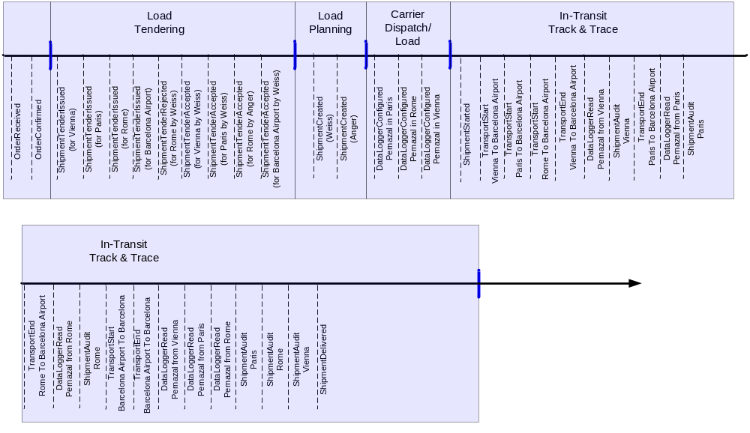

…
OrderReceived
Transport
Wien – Barcelona
Transport
Rom - Barcelona
Transport
Paris - Barcelona
Bestellung wird aufgeteilt
Teillieferungen werden am Flughafen zusammengefasst

Transport
Barcelona Airport -
Lager
OrderReceived.DeliveryDate

